HAZARD OBSERVED | RISK BEFORE CONTROL MEASURES | PERSONS  AT RISK | CONTROL MEASURES | COMMENTS  ACTIONS

Mobility Issues  Slips, trips & falls | Personal Injury | All attending | - Leaders with mobility issues to be based on bases to reduce risks of falls during activity bases  - Uneven terrain and different types of surface not suitable for mobility scooters  - Where previously advised groups will be positioned on campsites nearest toilet block to reduce walking as much as possible. | Groups to address this on individual colony camping RA.s
Activity Equipment  Unathorised use of Equipment  Equipment Failure | Personal Injuries | All Participating in Activity | - Ensure any equipment to be used should be fit for purpose  - Gazebos to be fasten down per manufacturing instructions  - Ensure faulty or damaged Equipment is reported to the leader in charge. | Faulty and Damaged Equipment not to be used
Manual Handling  Lifting Heavy or Awkwardly Shaped Objects | Personal Injuries  Muscle & Back Strain  Sprain & Strain | Leaders & Adult Helpers | - Ensure the use of Trolleys where appropriate.  - Ask for help from others, work within your physical limits.  - Consider the working environment – nature of the terrain.  - Adjust load so easier to carry (for example split load up and carry in smaller weights). | Ensure the Supervision of Young People for this task

Weather Conditions | Hypothermia  Heat Exhaustion  Dehydration  Sun Burn | All Participating in Activity | - Consider cancelling the event if Extreme weather conditions are predicted  - The Leader in Charge will assess the weather risk before and during the session and their decision on the abandonment of the session is final  - Ensure appropriate clothing is worn allowing for sudden changes in the weather  - Ensure some form of drinks station is available and plenty of water is consumed in Hot/Humid weather  - Ensure sun block is available and sun glasses are worn  - Ensure Hats are worn in Hot and sunny conditions | Ensure everyone is hydrated during hot weather. Leaders bring drinks to be available at own base throughout the da. There will be drinks break in morning and afternoon.  Hot water boiler will be available so that Leaders can make tea etc
First Aid  Minor Injuries  Insect Bites  Allergic Reaction  Heat Stroke  General Accidents | Sudden onset of illness | All Participating in Activity | - Ensure that all First Aiders are identified before the activity starts and they are fully briefed on their task  - Ensure their certificates are in date  - First Aiders made fully aware to use PPE when administering First Aid  - Ensure that all First Aiders are aware of anybody who suffers from Allergic Reactions participating in the activity  - Ensure that known Anaphylactic shock sufferers carry their Epipen or Anapen | Leader in Charge to ensure that all district paperwork is completed  Accident Form and Near Miss Form

SPECIFIC HAZARDS

The Leader in charge to list any specific hazards that are not covered by the Generic Activity Assessment above
or where special attention needs to be drawn

Name of assessor/Leader in Charge: Melanie Williams |  |  |  | Date of this assessment: 22.05.16
HAZARD OBSERVED | RISK BEFORE CONTROL MEASURES | PERSONS  AT RISK | CONTROL MEASURES |  |  | COMMENTS  ACTIONS
General potential hazards at Rhydd Camp Sites | Low | All attending the event | Pre event Inspection of camp sites where bases are to take place  All are used to attending Rhydd Covert and are aware of natural surroundings |  |  | This needs to happen before young people arrive for the bases
Moving between bases and campsites Beavers losing way around Rhydd | Medium | All | All young people, YLs and Adults will be made aware of the location of toilets, campsites being used, restricted areas. All young people should be accompanied by an adult when leaving central activity areas
Decorating Masks, making sock puppets, decorating jars for stage lights | Solvent abuse  Ingestion small objects  Injuries from from faulty equipment  Disruptive behaviour | All | Leader supervision during activity  Clear instructions on how to decorate masks, puppets & jars  Discard any faulty equipment and dispose of this at end of activity  Any young person misbehaving will be asked to sit out from the activity |  |  | 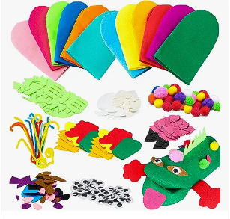
Popping corn – see camp fire section below for managing fires | Burns  Ingestion small objects  Faulty equipment  Disruptive behaviour | All | Experienced Rhydd Leaders to supervise activity  Specific corn popping equipment to be used to prevent corn from spitting  Water to be available  Leader supervision during activity  Any faulty equipment to be discarded & if necessary activity stopped  Activity to be stopped & young person misbehaving will be asked to sit out from the activity
Song base | Disruptive behaviour |  | Activity to be stopped & young person misbehaving will be asked to sit out from the activity
Parachute Games | Tripping over, falling whilst under parachute and slipping  Misuse of equipment  Faulty Equipment All | All attending the event | Appropriate footwear to be worn, all advised to take care when running under parachute, make sure all understand they need to be aware of others running underneath.  If weather is wet review whether it safe to continue with the activity  Leaders to brief all on how to safely hold parachute  Leader to check parachute for tears and other hazards before use
Musical Treasure Hunt | Slips trips & falls  Getting lost  Users wandering into areas where vehicles may be moving. Getting Lost / Panic Disorientation  Picking up foreign objects | All attending the event | Appropriate footwear to be worn, all advised to take care when searching for clues  Groups to be accompanied by their leaders to look for clues. Leader guidance to brief users on remaining in the woodland area and to avoid the car park areas Clear lines of sight for drivers in car park areas. 5mph speed limit in places  Young people to be advised not to pick up anything on the treasure hunt
Giant Inflatables – knockout challenge UK  https://www.knockoutchallenge.uk/ | Slips trips & falls from height  Disruptive behaviour | All | Risk assessment to be provided by outside company specific to activity.  Adult supervision  Clear instructions on how to use equipment  Any one not following rules of safely using inflatables, activity will be stopped & person asked to sit out  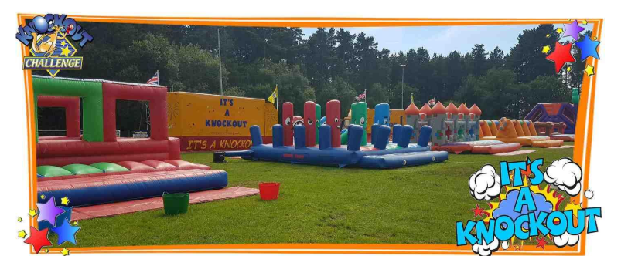
Fizz Pop Science – Backstage effects  https://fizzpopscience.co.uk/ | Dry ice, water | All | Risk assessment to be provided by outside company specific to activity.  Fizz Pop Science have been used before & regularly provide workshops on schools
Camp fire & fires for popping corn

Site of the fire and general considerations | Burns | All | - Ensure site of fire is appropriate:  - Ensure size of fire is appropriate  - Take careful considerations of wind direction  - Tie long hair back  - Advise children and leaders of boundaries around fire 3m  - Ensure first aid kit and water for treatment of burns |  | Rhydd Team & Leader in charge ensure this happens
Collecting of firewood: | Eye pokers  Scratches (from  bramble or  sticks)  Foot injury  Splinters  Nettle sting | Rhydd Team | - Demonstrate sizes of wood to be collected, both  thickness & length in age-appropriate terms |  | Rhydd Team ensures this happens

Fire lighting: | Burns | All participating in activity | - Adults start fire  - Young people to stay 3m from fire  - Young people must not run and must behave appropriately  - Fire managed so flames get no higher than 3m  - Marshalls in place to ensure no one accidently runs into fire area |  | Adult supervision at all times  Practice appropriate behaviour.  Bucket of water  First-aider present who understands how to deal  with cuts and burns
Extinguishing fire | Burns and  scalds |  | - Only adults should carefully extinguish fire.  - Leave area as it was found – return any unused wood to woodpile  Ashes & charred sticks should be spread over area and totally extinguished/covered |  | Rhydd Team to ensure this happens
Individual Colony campsite |  |  |  | Colonies to prepare own campsite RA
Inclement Weather  Heavy rain | Slips, trips, falls |  |  | Weather forecast to be reviewed week of event . Activity bases to be run under gazebos. Games to be adjusted to take slippery conditions into account. Camp fire to take place in large lunch marquee.  In event of storm/heavy winds event to be postponed

